URL: <http://www.dohms.gov.ae/Hospitals-Clinics/MainHospitals/DubaiHospital/>

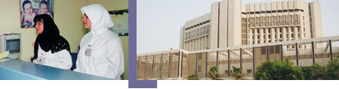

The hospital comprises numerous specialized departments and clinics, one of which is the cardiology center, which is a quality transformation in the services the authority offers in this field. To deliver comprehensive-preventive, curative and primitive-high-quality health care to patients using the hospitals and clinics as described in the scope of services.

**Services:** Anesthesia, ophthalmology, ENT, orthopedic, endocrinology, pediatric, nephrology, physiotherapy, nuclear medicine, radiology, oncology, urology, obstetrics and rhemotology

**Doctor in endocrinology**

|  |  |
| --- | --- |
| |  | | --- | | Dr Abdul Razzak Al Madani, Consultant Physician & endocrinology  Unit Head of medical department & Chief of endocrinology unit  Dr. Fadhil M Abdulla Specialist physician & endocrinology  Dubai Hospital  Tel No: 2195000 | |

|  |
| --- |
|  |

**Contact us:**

Dubai Hospital  
  
Tel: 04-2195000  
Fax: 04-2719340  
PO Box 7272 Dubai,

UAE